Lab: 2FA simple bypass
Lab Report
Prepared by: Nihar Mane

INDEX

2.1 Report Metadata.................................................................................................... 2
2.2 Executive Summary.............................................................................................. 2
2.3 Scope..................................................................................................................... 2
2.4 Methodology and Root Cause............................................................................... 2
2.5 Step-by-Step Execution........................................................................................ 3
2.6 Impact Assessment................................................................................................ 7
2.7 Remediation.......................................................................................................... 7
2.8 Conclusion............................................................................................................ 8
References
References................................................................................................................. 8

2.1 Report Metadata
Lab Name | 2FA simple bypass
Provider | PortSwigger Web Security Academy
Vulnerability class | Broken authentication → multi-factor authentication logic flaw → forced browsing past 2FA → account takeover
Difficulty | Apprentice
Target | PortSwigger Web Security Academy training instance
Tools used | Burp Suite Community Edition v2026.7.3, Burp's built-in browser, Lab's email client
Test account | Wiener/Peter (own account, used to observe the baseline flow)
Target account | Carlos/Montoya (credentials known per lab brief; 2FA inbox not accessible)
Date tested | 13 August 2026

2.2 Executive Summary
This engagement examined the two-factor authentication (2FA) flow on the “2FA simple bypass” lab from the PortSwigger Web Security Academy. The application's login process consists of two steps: a username/password check, followed by a 4-digit verification code emailed to the account holder. The lab brief provided a valid username and password for the victim account (Carlos) but withheld access to that account's inbox, meaning the correct 2FA code could not be retrieved.
A baseline login was first performed with a test account (wiener) to observe the intended flow end to end: password check, code entry, then redirect to /my-account. Logging in with the victim's credentials (carlos / montoya) reached the same “enter your 4-digit security code” prompt—but rather than submitting a code, the account page was requested directly by editing the browser's address bar. The application returned Carlos's account page without ever validating a 2FA code, because the session was already treated as fully authenticated after the password step alone.
This confirms that the second authentication factor exists only as a UI checkpoint and is not enforced server-side on protected resources. Any attacker who obtains a valid password — through credential stuffing, reuse, or phishing—can access the account in full by simply skipping the 2FA prompt, making the second factor provide no real additional security.

2.3 Scope
• In scope: the login flow (/login), the 2FA verification step (/login2), and the account page (/my-account) of the PortSwigger Web Security Academy lab instance.
• Out of scope: all other functionality of the lab, the underlying infrastructure that hosts it, and any system outside the training environment provided by PortSwigger.
• Testing was performed on a training instance provided and authorized by PortSwigger for this exercise, using credentials supplied by the lab itself. No real accounts or production systems were involved at any point.

2.4 Methodology and Root Cause
A correctly implemented 2FA flow should treat a session as only partially authenticated after the password step and should require a server-side “2FA verified” flag before granting access to any protected resource. This application instead appears to fully authenticate the session as soon as the password check succeeds—the 2FA code prompt is presented by the front-end flow, but nothing on the server actually blocks a request for /my-account from an already-password-verified session that hasn't submitted a code.
In other words, the 2FA step is enforced only as a matter of which page the user is shown next, not as a condition checked on protected endpoints themselves. This makes the second factor purely cosmetic: it can be skipped entirely by forced browsing directly to the intended destination.
The methodology followed was
• Log in with a known test account (wiener / peter) to observe the intended flow: password check → /login2 code prompt → /my-account.
• Retrieve the emailed 4-digit verification code via the lab's email client and submit it to complete the baseline login.
• Note the URL and structure of the account page once fully authenticated, for reference.
• Log out, then log in using the victim's credentials (Carlos/Montoya), reaching the /login2 code-entry prompt without submitting a code.
• Instead of entering a code, edit the browser address bar to navigate directly to /my-account.
• Observe whether the server serves the victim's account page despite no 2FA code having been submitted.

2.5 Step-by-Step Execution
Step 1 — Log in with the test account.
Logged in using the known test credentials (wiener / peter) to observe the application's intended two-step authentication flow from the start.
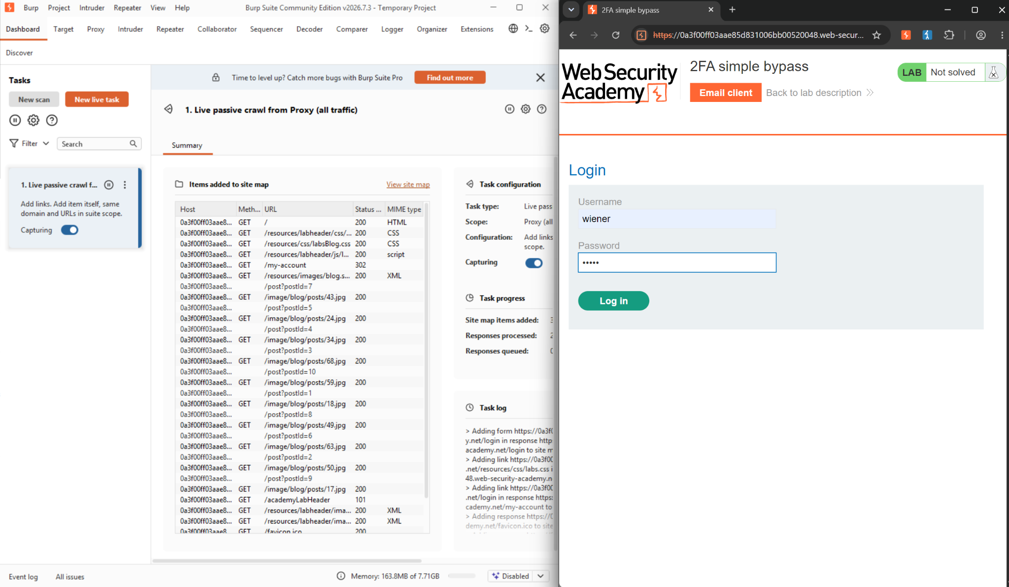
Figure 1: Login with test credentials wiener / peter, alongside the “2FA simple bypass” lab page.

Step 2 — Retrieve and submit the verification code.
The lab's email client showed the 4-digit security code sent to wiener's inbox. This code was entered on the /login2 prompt to complete the baseline login.
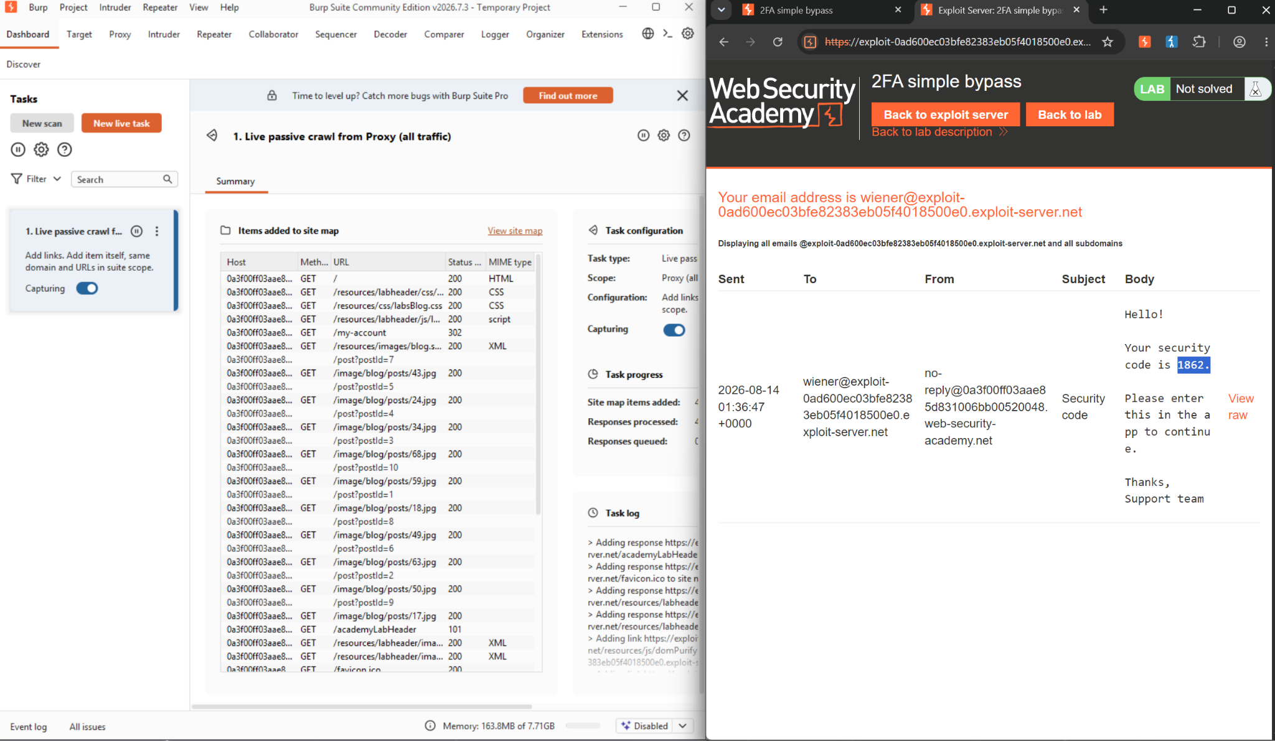
Figure 2: Email client showing the 4-digit security code (1862) sent to wiener's exploit-server inbox.

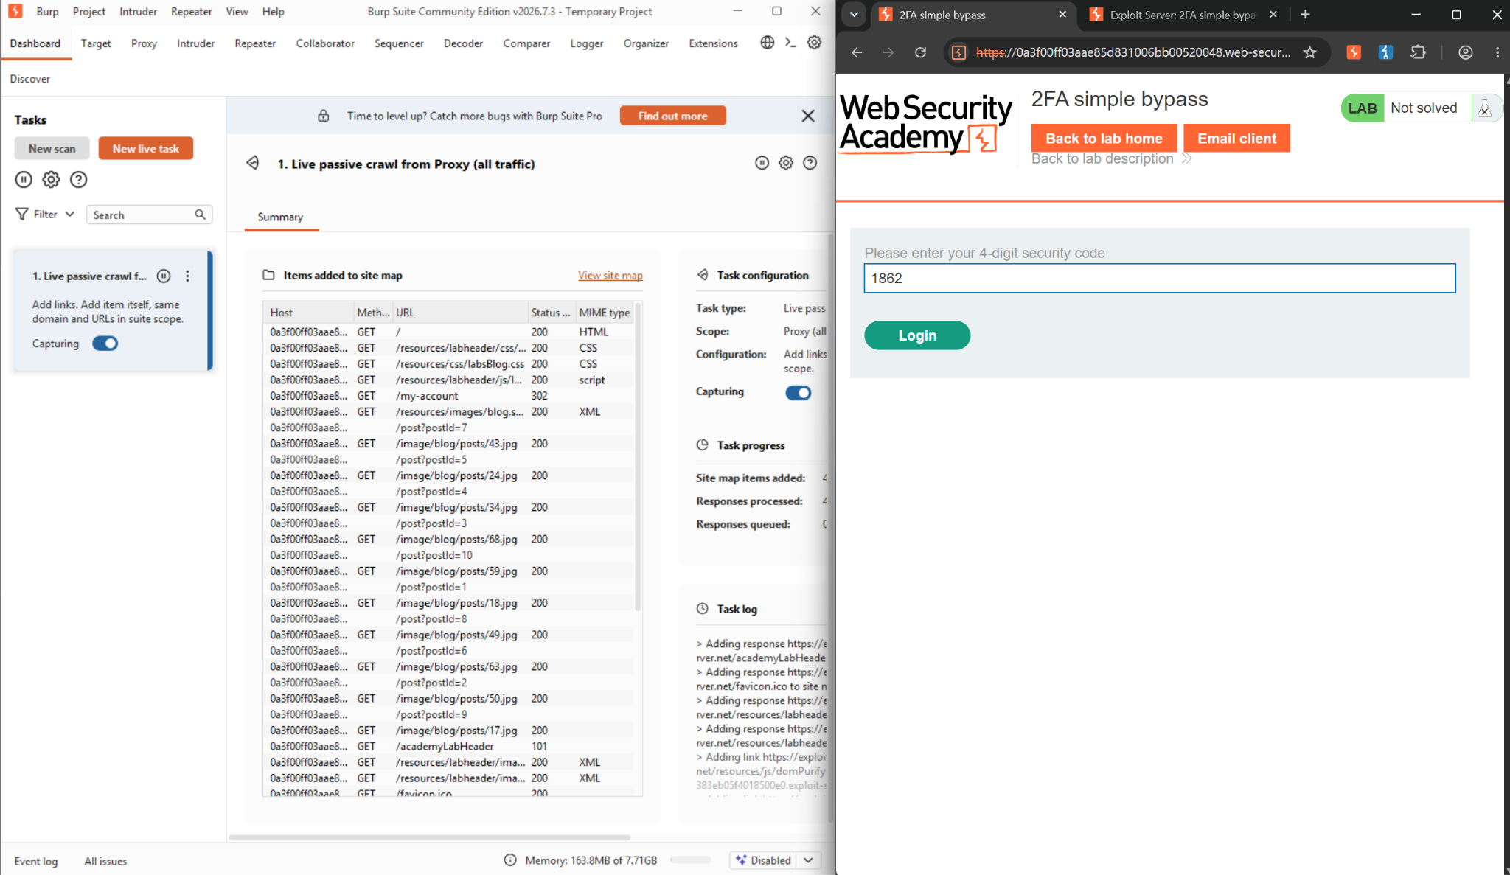
Figure 3: The 4-digit code entered on the /login2 verification prompt to complete the baseline flow.

Step 3 — Note the account page after full authentication.
Once the code was accepted, the application loaded /my-account, confirming the intended end state of a fully completed login for reference against the exploit attempt.
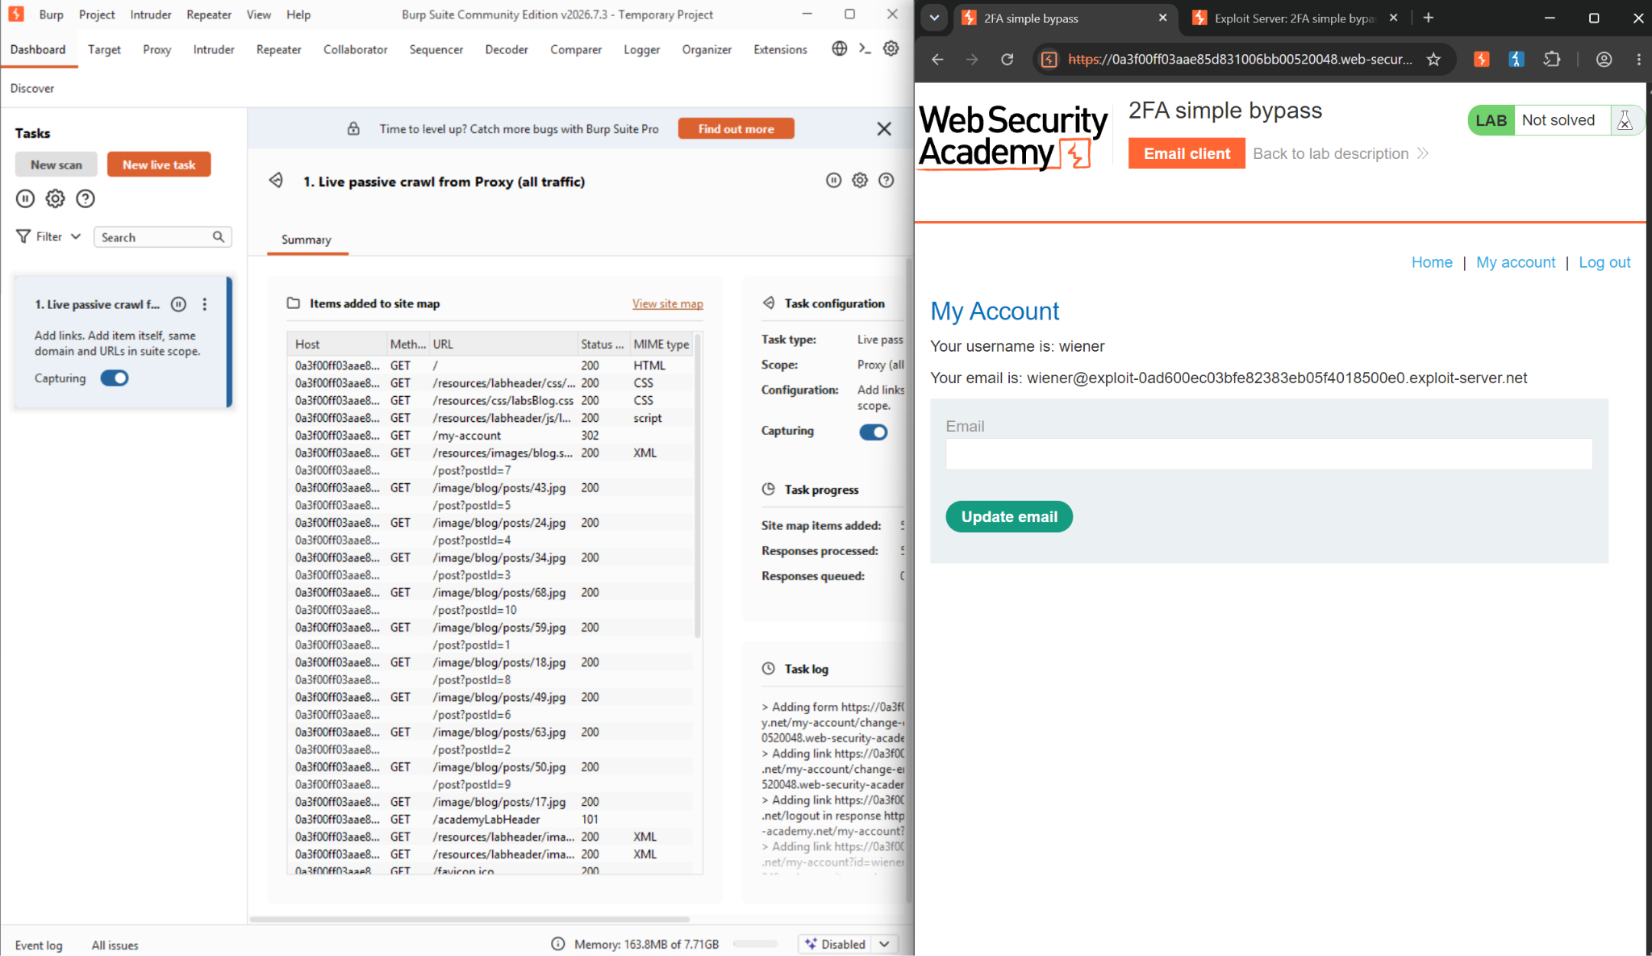
Figure 4: My Account page reached after completing both authentication factors for wiener.

Step 4 — Log in as the victim.
Logged out and logged back in using the victim's known credentials (carlos / montoya). As with the baseline flow, this reached the “enter your 4-digit security code” prompt — but the code for this inbox was not available.

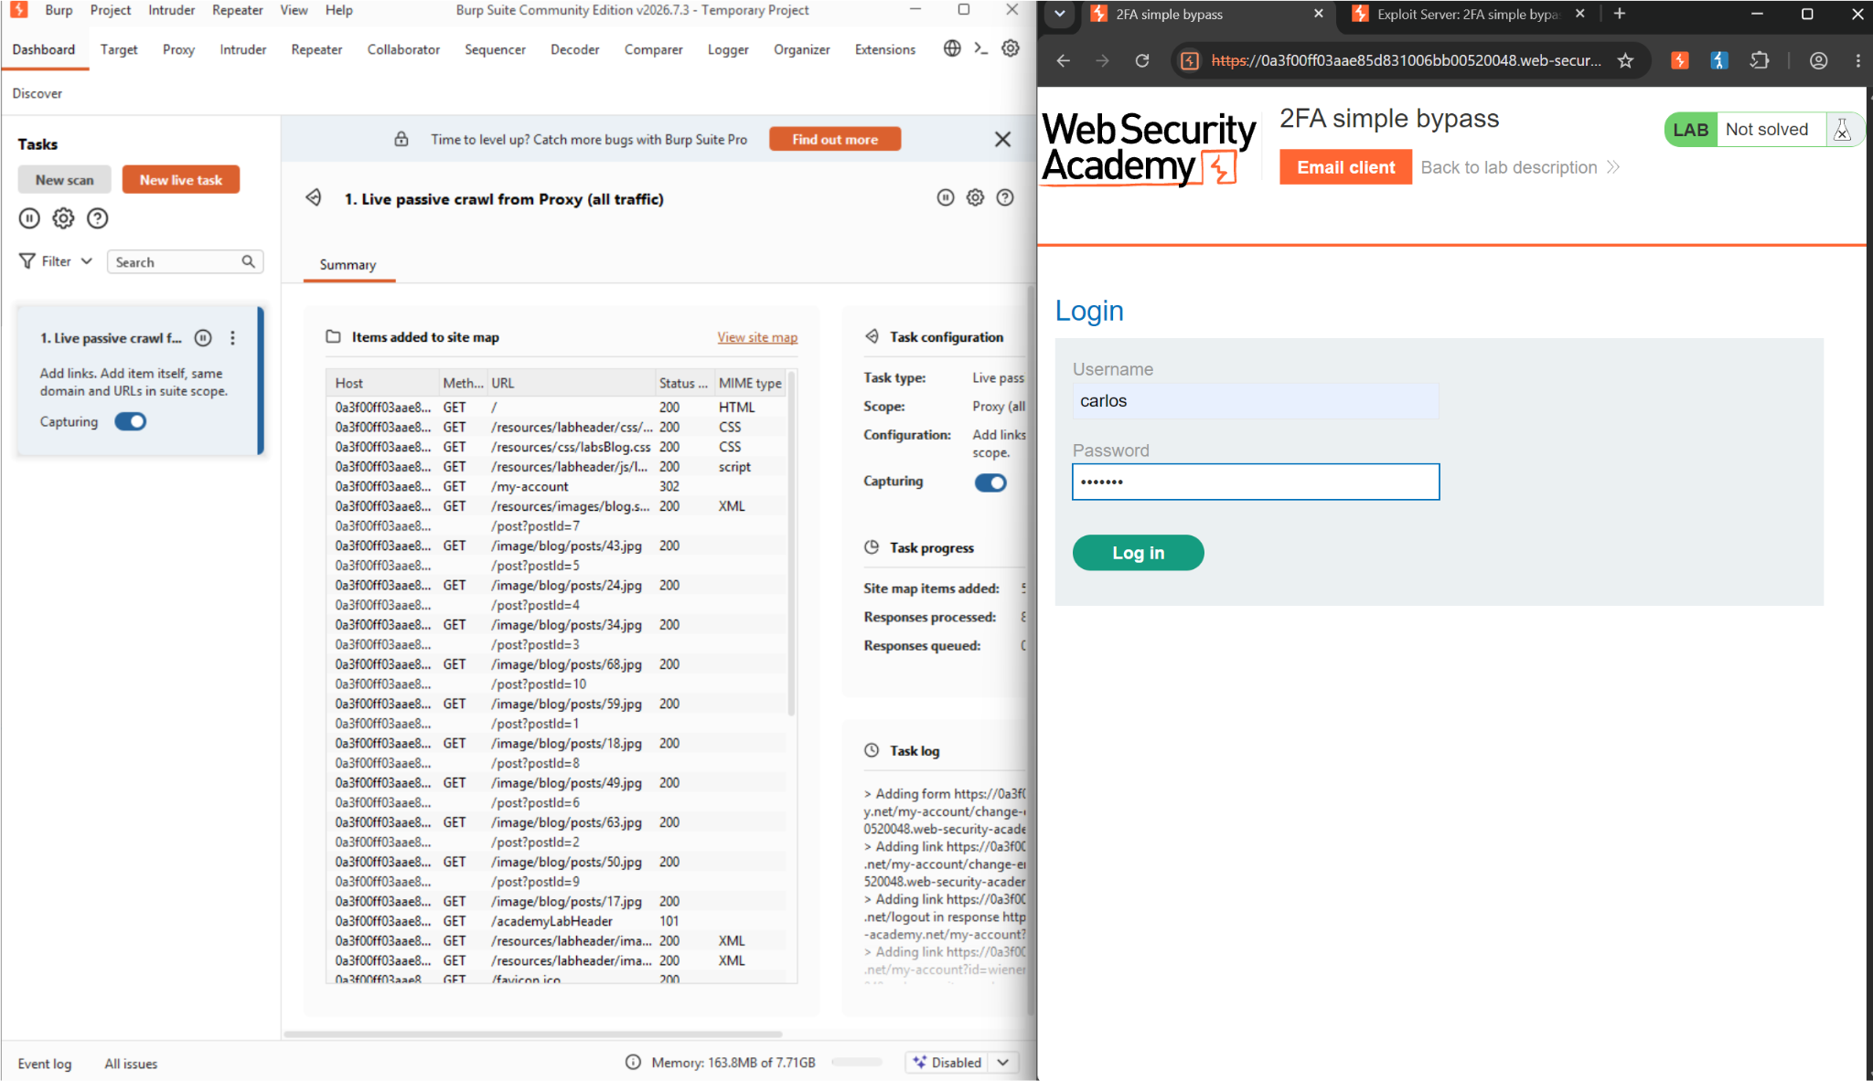
Figure 5: Logging in with the victim's credentials, carlos / montoya .

Step 5 — Bypass the 2FA prompt by forced browsing.
Rather than supplying a code, the browser's address bar was edited to navigate directly to /my-account, testing whether the server would enforce the pending 2FA requirement on that endpoint.
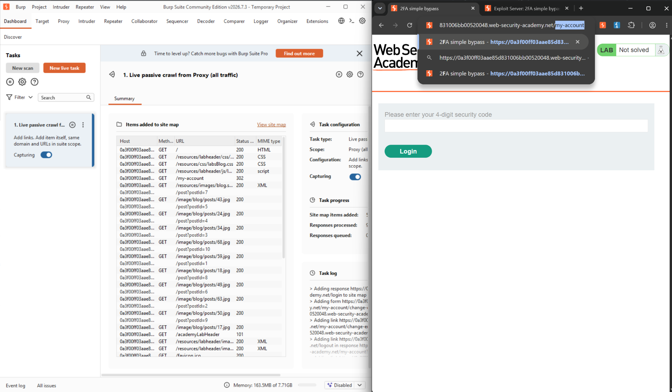
Figure 6: Address bar edited to browse directly to /my-account instead of submitting a 2FA code.
Step 6 — Confirm the bypass and account takeover.
The application served Carlos's account page directly — username carlos, email carlos@carlos-montoya.net — without ever validating a 2FA code, and the lab's “Solved” banner confirmed the bypass.
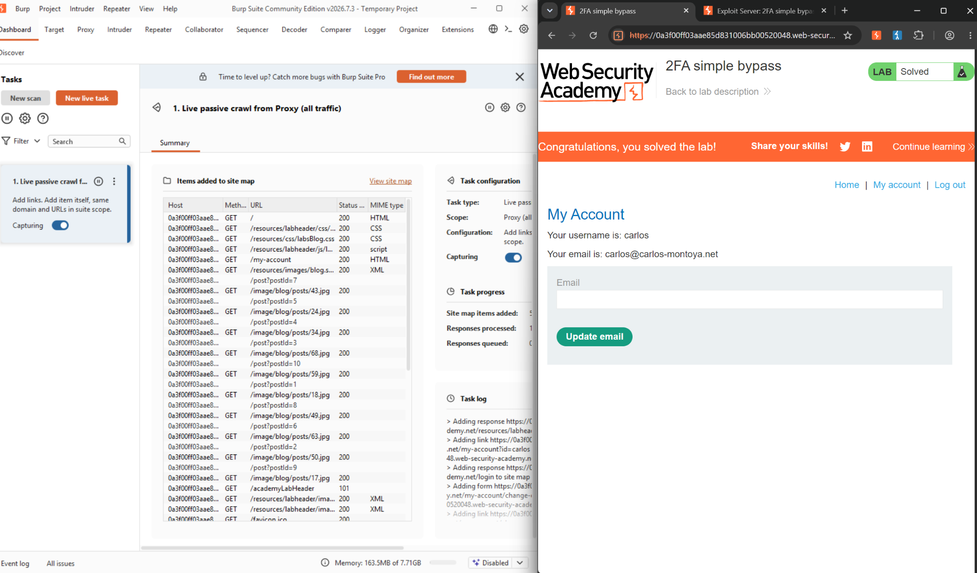
Figure 7: “Congratulations, you solved the lab!” banner with Carlos's My Account page, reached without completing 2FA.

2.6 Impact Assessment
Two-factor authentication exists specifically to protect an account when its password has been compromised through means such as credential stuffing, reuse, or phishing. If the second factor can be skipped by simply requesting the destination page instead of submitting a code, it provides no actual security benefit—any attacker who obtains a valid password gains full account access without ever needing the victim's device, inbox, or authenticator app.
This is particularly severe because organizations that deploy 2FA typically treat it as a strong mitigation against password compromise, potentially relaxing other controls (such as password complexity monitoring or breach-credential checks) on that assumption. A logic flaw like this one silently removes that protection while leaving every visible indicator—the 2FA prompt itself—intact, making the weakness easy to miss without explicitly testing whether protected endpoints enforce the second factor, rather than just the login page presenting it.

2.7 Remediation
• Track 2FA state explicitly and server-side: mark the session as only partially authenticated after the password step, and set a distinct “2FA verified” flag only once the correct code is submitted.
• Enforce that flag as an authorization check on every protected endpoint (e.g. /my-account), not just as a front-end redirect — reject or redirect any request from a session that hasn't completed 2FA.
• Avoid identifying the target account via a client-influenced parameter; derive the account strictly from the server-side session rather than trusting a URL or request value.
• Apply rate limiting and lockout to the 2FA code-entry step to prevent brute-forcing of the 4-digit code as a separate attack path.
• Include authentication logic flows—not just individual endpoints—in test coverage, specifically checking whether each step of a multi-step flow can be skipped via forced browsing.

2.8 Conclusion
This exercise demonstrated a complete 2FA-bypass-to-account-takeover chain against the “2FA simple bypass” lab. Steps 1–3 established the intended flow using a test account: password check, emailed code, then access to the account page—confirming what a correctly completed login looks like.
Steps 4–6 showed that this second factor was never actually enforced: logging in with the victim's password reached the same code prompt, but navigating directly to /my-account succeeded regardless, without any code ever being submitted. Reaching Carlos's account page and the lab's “Solved” state confirmed the second factor could be bypassed entirely by forced browsing.
This lab complements the Week 2 authentication and session-state work directly: where the username enumeration lab showed that a login endpoint can leak more than it should through its responses, this lab shows the same underlying category of mistake at the session layer—trusting a session as “logged in” before every step of login has actually been completed. Both findings point to the same broader principle: authentication is only as strong as the checks the server actually performs on every request, not the steps a well-behaved client is merely expected to follow.

References
• 2FA simple bypass (lab) https://portswigger.net/web-security/authentication/multi-factor/lab-2fa-simple-bypass

